THE ROLE OF CREDIT RISK AS A MEDIATOR IN IMPROVING SHARIA BANK PERFORMANCE IN INDONESIA

Julia Safitri^{1*}
Arinal Rahmati ²
Jayadi Jayadi ³
Muhamad Arief Affandi ⁴
¹Sekolah Tinggi Ilmu Ekonomi IPWI Jakarta
² STIS Ummul Ayman, Pidie Jaya
³ Sekolah Tinggi Ilmu Ekonomi IPWI Jakarta
⁴ Ph.D. Student at Faculty Economic and Business, Trisakti University

^{*1}Email: julia.ipwija@gmail.com, ²Email: arinalrahmati@gmail.com, ³Email: djayadi.ipwija@gmail.com, ⁴Email: affandiarief5@gmail.com

ABSTRACT – This study aims to see how the distribution of third party funds in the form of savings, deposits etc. can work as it should be where liquidity plays an important role in the management of public funds. Liquidity management controls liquid assets that are easy to pay for in order to meet all bank obligations that must be paid immediately. This study used 14 samples of Islamic banks listed on the IDX 20013-2019, using an analysis tool, namely Warp PLS 7.0. The results show that the variable that becomes the research gap in this study, namely the effect of liquidity on bank performance, which is mediated by credit risk, has proven significant, in line with the Commercial Loan Theory which states that it is better to provide loans in the short term, thereby minimizing the occurrence of defaults by customers.
Keywords: Islamic Banking, Commercial Loan Theory, Liquidity, Noan Performing Financing.

ABSTRAK – Peran Risiko Kredit sebagai Pemediasi dalam Meningkatkan Kinerja Bank Syariah di Indonesia. Penelitian ini bertujuan ingin melihat bagaimana penyaluran dana pihak ketiga yang berupa tabungan, deposito dll dapat berjalan sebagaimana mesti nya dimana likuiditas berperan penting dalam pengelolaan dana masyarakat. Manajemen likuiditas pengendalian alat-alat likuid yang mudah ditunaikan guna memenuhi semua kewajiban bank yang harus segera dibayar. Penelitian ini menggunakan 14 sampel bank Syariah yang terdaftar pada BEI 20013-2019, menggunakan alat analisis yaitu Warp PLS 7.0. Hasil menunjukan bahwa variabel yang menjadi research gap penelitian ini yaitu pengaruh likuiditas terhadap kinerja bank yang di mediasi oleh risiko kredit berhasil terbukti signifkan, sejalan dengan Commercial Loan Theory yang menyatakan bahwa sebaikanya memberikan pinjaman dalam waktu jangka pendek, sehingga meminimalisirkan terjadinya gagal bayar oleh nasabah.
Kata Kunci: Bank Syariah, Teori Commercial Loan, Likuiditas, Risiko Kredit

© SHARE Jurnal Ekonomi dan Keuangan Islam  ISSN: 2089-6239 (P); 2549-0648 (E) | Vol. XX, No. X, 20XX; pp. 1-19  DOI: 10.22373/share.v6i1.XXXX

INTRODUCTION
The revival of the current Islamic economy is not only related to expanding economic sectors spread to various domains life. But more importantly there is also an increase in awareness people in economics and doing business from the Ribawi to switch to business based on Islam (sharia). In the course of time, there have been lots of new problems occurring or the emergence of new problems, in practice there have often been economic disputes between the parties in the transaction which have created inevitable legal problems. Jasevičienė et al., (2013) Banking financial institutions carry out three main functions, namely collecting funds from the public as the owner of funds, channeling funds to the community as users of funds and providing services and also as a means of community welfare. In carrying out its functions of the bank, some people view that with the conventional system there are things that are not in accordance with the beliefs of the Indonesian people, who are predominantly Muslim, who refuse interest as the determination of rewards and charges (Tobin, 1958). In practice, the interest applied to conventional banks can actually be detrimental for both the bank and the customer. So that the Islamic banking system can be considered more resilient in facing crises.
According to Amelia, (2015) in line with the development of the Islamic economic sector, many conventional banks show that the level of liquidity plays an important role for banks. Banking conditions that are experiencing liquidity difficulties have prompted the banking world to raise high interest rates in order to attract funds from the public (Siddiqui, 2008). The existence of a Sharia banking system is in line with Law Number 7 of 1992 concerning banking, which stipulates that bank business activities must be perfected and apply the principle of prudence. The operational foundation of the Sharia banking system is getting stronger with the issuance of Government Regulation No. 72 of 1992 which has been replaced by Government regulation no. 30 of 1999 concerning banks based on the principle of profit sharing. Then with the enactment of Law No. 3 of 2004 grace period for amendments to Law no. 23 of 1999 concerning Bank Indonesia, two banking systems are applied conventionally and or based on Sharia principles (dual banking system), and specifically for Islamic banks only use Sharia principles. In fact there is a continuation of Law no. 21 of 2008 concerning Islamic banking, it is hoped that the direction towards usury-free banking is achieved more quickly. Liquidity management is the ability of a company to fulfill its financial obligations which must be fulfilled immediately. The number of payment instruments (liquid assets) owned by a company at one time is the power to pay the company concerned. Akhtar et al., (2011) if a company that has the power to pay may not be able to fulfill all its financial obligations that must be fulfilled immediately or in other words, the company does not necessarily have the ability to pay. According to Modigliani, (1944) Liquidity is the ability of a bank to meet its funding needs (cash flow). The functions of liquidity are: first, carrying out business transactions. Second, overcoming urgent funding needs. Third, satisfying customer demand for loans and providing flexibility in seizing investment opportunities.
The four objectives of liquidity management are: first, to maintain the bank's liquidity position so that it is always in the position determined by the monetary authority, namely Bank Indonesia. Second, managing liquid assets to meet all cash flow needs, including unexpected needs, such as sudden withdrawals of a number of demand deposits or time deposits that have not yet matured. Third, minimize idle funds (idle funds). Fourth, maintaining the liquidity position and cash flow projection so that it is always in a safe position, especially in terms of fluctuating interest rates. Assessment of the capital ratio commonly used to measure bank health is the Capital Adequacy Ratio (CAR) which is based on the ratio of capital to risk weighted assets (RWA), as stipulated in the Decree of the Board of Directors of Bank Indonesia Number 26/20 / KEP / DIR concerning Liabilities. Capital Adequacy Ratio (KPPM) and Bank Indonesia Circular Letter Number 26/2 / BPPP concerning Minimum Capital Adequacy Requirement. With the increase in own capital, the health of the bank which is related to the capital ratio (CAR) will increase. Since the crisis period to date, CAR has become the main reference in determining the health of a bank (SK Dir BI April 1999), where one of the API programs requires the minimum capital for commercial banks (including BPD) to be 100 billion with a minimum CAR of 8% no later than in 2010. Ezike & Oke, (2013) CAR is a capital ratio that shows the bank's ability to provide funds for business development needs and accommodate the risk of loss of funds caused by bank operations. CAR shows the extent to which the decline in bank assets can still be covered by the available equity of the bank (Bhattacharya, 2013). The higher the CAR, the more capital the bank has to cover the decline in assets.
LITERATURE REVIEW
Basically, liquidity management theory is a theory relating to how to manage bank funds and sources of funds in order to maintain a liquidity position and meet all liquidity needs in the bank's daily operations. Several theories of liquidity management are known in the banking world.
Commercial loan theory.
This theory assumes that banks are only allowed to provide loans with short-term commercial papers which can be disbursed by themselves (self-liquidating). This theory is also known as the productive theory of credit, or often called the real bills doctrine which was introduced since the 18th century. This theory was quite dominant until the 1920s. In principle, this theory focuses on the asset side of the bank's balance sheet in meeting the bank's liquidity needs. According to this theory, bank liquidity can be guaranteed if the bank's productive assets consisting of short-term credit are disbursed in business activities that are running normally. And if the bank concerned is going to provide longer credit, the data source should be taken from bank capital and long-term sources of funds.
Shiftability Theory.
This theory assumes that the liquidity of a bank depends on the bank's ability to transfer its assets to other people at predictable prices. In the 1920s, banks developed liquidity theory as a reaction to the many weaknesses in the commercial loan theory, namely the doctrine of asset shiftability. According to this theory, banks can immediately meet their liquidity needs by providing shiftable loans or call loans, which are loans that must be paid with one or several days' notice with securities as collateral. Therefore, if a bank needs liquidity at any one time, this need can be met by invoicing the borrower or debtor.
Anticipated Income Theory.
Also called the theory of expected income. This theory concludes that it is absolutely correct for a bank to provide long-term loans and non-commercial loans. In the 1930s and 1940s, banks developed a new theory called the anticipated income theory. This theory states that banks should be able to provide long-term credit where repayment, namely loan principal installments plus interest, can be expected and scheduled for future payments according to a predetermined time period..
Liabilty Management Theory.
This theory sees the structure of bank assets as having a prominent role to play in providing liquidity for banks. This theory also goes beyond the one-dimensional approach and states that banks can also use their assets for liquidity purposes.

Hypothesis
The Effect of Liquidity on Bank Performance
The financial performance of the bank in this study is profitability with return on assets (ROA) indicator which is calculated from profit before tax divided by total assets (Idowu et al., 2002). ROA provides information on the net income generated per unit of monetary asset invested so that it also provides information on the ability of bank management to invest in bank assets. Liquidity carried out by banks is measured by the loan to funding ratio (LFR), which is effective (Toby1, 2014) if the bank can channel all its sources of funds in the form of credit after calculating the required reserve and liquidity This shows that the higher the loan to deposit ratio, the more productive the source of funds owned by the bank, the higher the bank's profit.
H1: Liquidity has a positive effect on Bank Performance.
Effect of Capital Adequacy on Bank Performance.
The capital adequacy standard for banks operating internationally is a major concern for regulatory banks around the world. Because of this, the Bank for International Settlements (BIS) established a framework for measuring capital adequacy for banks in the group of ten (G10) banking industry countries in the world. Capital adequacy standards affect bank performance (John Emeka Ezike, 2013) Capital Adequacy Ratio (CAR) as an indicator of a bank's ability to cover a decline in assets as a result of losses suffered by a bank, the size of the CAR is determined by the bank's ability to generate profits and the composition of the allocation of funds to assets according to the level of risk.
H2: Capital Adequacy has a positive effect on Bank Performance
The Effect of Interest Rate Risk as a Liquidity Mediator on Bank Performance.
Credit risk is a risk that promises cash flow from loan income and other securities held by financial institutions that may not be fully repaid. Credit risk dominates the composition of the capital adequacy ratio, where 70% of capital is allocated for credit risk and 30% for market risk and operational risk. Thus credit risk is the main cause of bank failure and the risk is most visible to bank managers (Garr, 2013). There is limited empirical research that examines the factors that influence credit risk. Bank risk is closely related to economic conditions and business turnover. When economic conditions experience a downturn / sluggishness, problem loans will also increase in number, at a time when the economy is booming (booming economics) will increase the volume of cash held by businesses or households, this will increase people's purchasing power so that the ability to repaying loans is increasing. This has reduced bank credit risk.
H3: Credit Risk Can Mediate the Effect of Liquidity on Bank Performance.
Based on hypotheses 1, 2, and 3, Hypotheses 4 and 5 can be submitted, namely:
H4: Credit Risk can mediate the Effect of Liquidity on Bank Performance
H5: Credit Risk Has a Positive Effect on Bank Performance
METHODOLOGY
Types and Sources of Data
The object of this research is Islamic banking companies listed on the stock exchange for the period 2013 to 2019. The type of data in this documentary is data in the form of financial reports of Islamic banking companies in Indonesia for the period 2013-2019. The data source is secondary data, namely data obtained from other parties, in this case the data source is the Indonesian stock exchange in the form of financial reports (annual report) with the address www.idx.co.id. and bloomberg.Populasi dan Sampel.
The sampling technique in this study used purposive sampling, which is sampling based on objectives or based on certain criteria. The criteria for sampling are as follows:
1. Sharia banking companies listed on the Indonesian stock exchange and published financial reports for the 2013-2019 period.
2. Banking companies that have complete data related to this research variable. So that a large sample can be obtained.
Data Analysis Techniques
The empirical research model in this study is set out in the form of a path diagram, so that the data analysis method used is path analysis. Path analysis is an extension of multiple linear regression analysis, or path analysis is the use of regression analysis to estimate the causal relationship between variables that have been predetermined based on theory. The variables in this study use a ratio measurement scale, so the appropriate technique to use is econometric techniques. From the research objectives, the research model used, the type of data and the measurement scale of the research variables, the regression used was panel path analysis fund regression, the calculation of the panel path analysis data regression coefficient using computer software eviews.
Regression Equations:
ROA = γ+β₁ LFR + β₂ CAR + β₃ NPF +ε₁…………..(1)
NPF = γ+β₁ LFR + β₂ CAR+ ε₂……………………...(2)
RESULT AND DISCUSSION
Research Model Evaluation Analysis
The evaluation analysis of the research model as described earlier includes two stages, namely evaluation of the measurement model and evaluation of the structural model. Model evaluation analysis using the PLS SEM method with the application of Warppls version 7.0. The algorithm method used in this study for the outer model uses PLS mode A because all constructs in this study use reflective indicators, for the inner model uses linear because it is assumed that all relationships between constructs in the model are linear. For the resampling method using Stable, selecting Stable based on the resampling method results in the stability of the estimated path coefficient or produces a smaller P value compared to other methods (Sholihin and Ratmono, 2013).
Structural Model Evaluation
The evaluation of the structural model (inner model) aims to predict the relationship between variables by seeing how much variance can be explained and knowing the significant P-value (Latan and Ghozali, 2016). Thus through the evaluation of the structural model can answer hypothesis testing in this study, namely hypotheses 1, 2 and 3. As for hypothesis 4 (the effect of mediation) will be tested through mediation testing in the next analysis. Before evaluating the relationship between constructs, first evaluate the goodness of fit of this research model which can be seen in the output in Table 1.

Table 1. Goodnes of Fit Model Structural
Kriteria | Parameter
Average path coefficient (APC) | 0.196/ P<0.03
Average R-squared (ARS) | 0.103/ P<0.1
Average adjusted R-squared (AARS) | 0.070/ P<0.1
Average block VIF (AVIF) | 1.035
Average full collinearity VIF (AFVIF) | 1.040
Tenenhaus GoF (GoF) | 0.321
Sympson's paradox ratio (SPR) | 1.000
R-squared contribution ratio (RSCR) | 1
Statistical suppression ratio (SSR) | 0,8
Source: Secondary data processed (2020)
Based on Table 1. above, it can be seen that this research model has a good fit, where the P value for APC <0.05, ARS and AAR <0.1, with an APC value = 0.196, ARS value = 0.103 and AARS value = 0.70. Likewise, the resulting AVIF and AFVIF values are <3.3, which means that there is no multicolonierity problem between indicators and between exogenous variables. The resulting GoF is 0.321> 0.1 which means that the fit of the model is very good. For SPR and RSCR it produces a value equal to 1 while SSR is with a value of 0.8> 0.7 which means there is no causality problem in the model (Latan and Ghozali, 2016).
Testing hypotheses 4 and 5 requires a mediation testing method. In this study, the mediation test used the Variance Accounted For (VAF) method. According to Hair et al. (2013) the procedure for testing mediation using the VAF method is as follows:
1. Testing the direct effect of exogenous variables on endogenous without including the mediating variable.
2. If the direct effect above is significant, then test the indirect effect of exogenous variables on endogenous by including the mediating variable.
3. If the indirect effect above is significant, then calculate the value of the VAF and determine the mediation effect with the following criteria:
a. VAF> 80% means that there is full mediation.
b. 20% <VAF <80% means that there is partial mediation
c. VAF <20% means no mediating effect in the model.
To calculate the Variance Accounted For (VAF) it is calculated by dividing the indirect effect by the total effect (direct effect plus indirect effect).
Table 2. The direct effect of the LFR, CAR variables on ROA
Description Path | Path Coefficient | P value
LFR--> ROA | 0.292 | 0.006
CAR--> ROA | 0.181 | 0.133
Source: Secondary data processed (2020)
Based on Table 2 it can be seen that LFR has a significant direct effect with p-value <0.006 on ROA, while CAR does not have a significant direct effect on ROA with a p-value of 0.133 so that it can be concluded that only the LFR variable has the potential to be mediated by NPF in indirectly affecting ROA. So from these results it can be stated that NPF does not mediate the indirect effect of CAR on ROA so that it rejects Hypothesis 4.
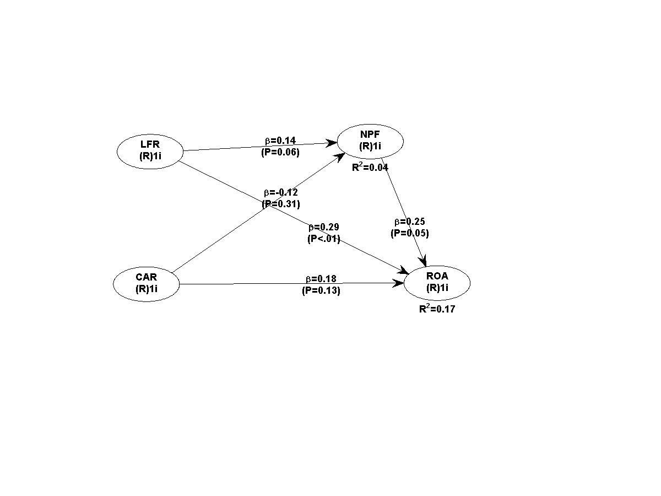
Figure 1. Research Model
Source: data processing results (2020)
CONCLUSIONS
This study aims to test empirically the effect of liquidity and capital adequacy on bank performance through credit risk. The study was conducted on Islamic banking companies listed on the IDX, with up to 14 Islamic banking companies, with a time frame of 2013-2019. The results of the study found that liquidity has a significant effect on bank performance, as well as proven credit risk to mediate the indirect effect of liquidity on bank performance. Which means that the Commercial Loan theory proves that bank liquidity according to this theory will be guaranteed if the bank's productive assets consisting of short-term loans are disbursed in business activities that are running normally. However, on the other hand, capital adequacy does not have a significant effect on bank performance, as well as credit risk which does not mediate the effect of capital adequacy on bank performance. In line with this, it can be explained that in both Islamic and conventional banks, capital is the main thing, but the opinion of lending is one of the things that becomes the benchmark for improving bank performance. Agree with Chen, (2003) which states that the level of the Capital Adequacy Requirement or CAR of a bank will be influenced by 2 main factors, namely the amount of capital owned by the bank and the amount of Risk Weighted Assets (RWA) managed by the bank.
REFERENCES
Akhtar, M., Ali, K., & Sadaqat, S. (2011). Liquidity risk management: a comparative study between conventional and Islamic banks of Pakistan. Interdisciplinary Journal of Management, 1(January), 35–44. http://core.kmi.open.ac.uk/download/pdf/1138057.pdf
Amelia, E. (2015). Financial Ratio and Its Influence to Profitability in Islamic Banks. Al-Iqtishad: Journal of Islamic Economics, 7(2), 229–240. https://doi.org/10.15408/ijies.v7i2.1700
Bhattacharya, H. (2013). CAPITAL REGULATION AND RISING RISK OF BANKING INDUSTRY : Hrishikes Bhattacharya , Formerly of Indian Institute of Management Calcutta. 12(1), 31–60. https://search.proquest.com/docview/1357052117/fulltextPDF/74DE60E349B04DFAPQ/1?accountid=14565
Chen, J. (2003). Capital adequacy of Chinese banks: Evaluation and enhancement. Journal of Banking Regulation, 4(4), 320–327. https://doi.org/10.1057/palgrave.jbr.2340149
Ezike, J. E., & Oke, M. . (2013). Capital adequacy standards, basle accord and bank performance: the nigerian experience (A case study of selected Banks in Nigeria). Asian Economic and Financial Review, 3(2), 146–159.
Jasevičienė, F., Povilaitis, B., & Vidzbelytė, S. (2013). Commercial Banks Performance 2008–2012. Business, Management and Education, 11(2), 189–208. https://doi.org/10.3846/bme.2013.11
Modigliani, F. (1944). Liquidity Preference and the Theory of Interest and Money. Econometrica, 12(1), 45. https://doi.org/10.2307/1905567
Olagunju&Adeyanju&Olabode. (2011). Liquidity Management and Commercial Banks’ Profitability in Nigeria. Research Journal of Finance and Accounting, 28(7), 24–39.
Siddiqui, A. (2008). Financial contracts, risk and performance of Islamic banking. Managerial Finance, 34(10), 680–694. https://doi.org/10.1108/03074350810891001
Tobin, J. (1958). Liquidity preference as behavior towards risk. Review of Economic Studies, 25(2), 65–86. https://doi.org/10.2307/2296205

