APPENDICES
APPENDIX 1: TEST INSTRUMENT

PART A
Direction: One of the underlined words or group of words in the following sentences is INCORRECT. Locate it and circle either [a], [b], or [c] underneath your chosen answer.

Example:
The news nowadays are always full of stories about people who are unhappy.
[a] [b] [c]

Please answer the following questions!
- The interrogation, conducted by three police officers, have lasted for several hours.
[a] [b] [c]
- The witnesses admit that most of the fire in the hills were extinguished.
[a] [b] [c]
- Some of the animals from the zoo was released into the animal preserve.
[a] [b] [c]
- Segregation in public schools was declare unconstitutional in 1954.
[a] [b] [c]
- The North Platte River flowing from Wyoming to Nebraska
[a] [b] [c]
- On the rim of the Kilauea volcano in the Hawaiian Islands are a hotel called the VH.
[a] [b] [c]
- Either the manager or her assistant are willing to help you with your refund.
[a] [b] [c]
- Dining in a restaurant is more fun than to eat at home.
[a] [b] [c]
- A patient suffering from amnesia may had partial or total loss of memory.
[a] [b] [c]
- The boy had never be stung by a bee.
[a] [b] [c]
- Cameos can be carved not only from onyx and sardonyx or from agate.
[a] [b] [c]
- In the evening he relaxes in front of the fire and writes long poets.
[a] [b] [c]
- The sycamore has broad leaves with a large amount of pointed teeth.
[a] [b] [c]
- When children experience too much frustration, its behaviour ceases to be integrated.
[a] [b] [c]

PART B
Please answer each of the following questions carefully!

Example:
The company involved in the project has (have) agreed to resume the work.
The amount of water that a camel has to drink daily is (be) unbelievably huge.

Question 1 – 10
Direction: Complete each of the following sentences by using the correct form of the word in the parentheses!

- My brother, along with his friends, …….…. (have) visited Germany several times.
- The authority has confirmed that a number of people …….…. (be) involved in the accident last week.
- Some of the students from the school …….…. (be) arrested by the police yesterday.
- The case of bullying in schools …….…. (have) been steadily increasing since the last couple of years.
- The Thames, running 140 miles from its source, …….…. (flow) constantly through the city of London.
- To the north of Syiah Kuala University …….…. (be) an Islamic university known as UIN Ar Raniry.
- Either Abdul or his brother …….…. (love) to participate in every contest.
- Sleeping in a remotely located private bungalow surrounded by magnificent natural views is much more enjoyable than …….…. (stay) in a five star high street hotel.
- Eating organic foods can …….…. (help) prevent poisonous materials from entering our body.
- Usman has never …….…. (be) to Singapore.

Question 11 – 14
Direction: Complete each of the following sentences by referring to the underlined word(s) and hint(s) provided.

- Jewelleries can be made not only from gold …………….…. from silver.
- If a painter produces paintings, a poet writes …….………! (hint: poet = penyair)
- A camel needs a large …………...…. of water in order to survive in a desert.
- When a large number of people live in a congested area, …….…. living standard may decrease. (hint: pronoun)
<<< Thank You >>>
APPENDIX 2: TABLE OF RESULTS
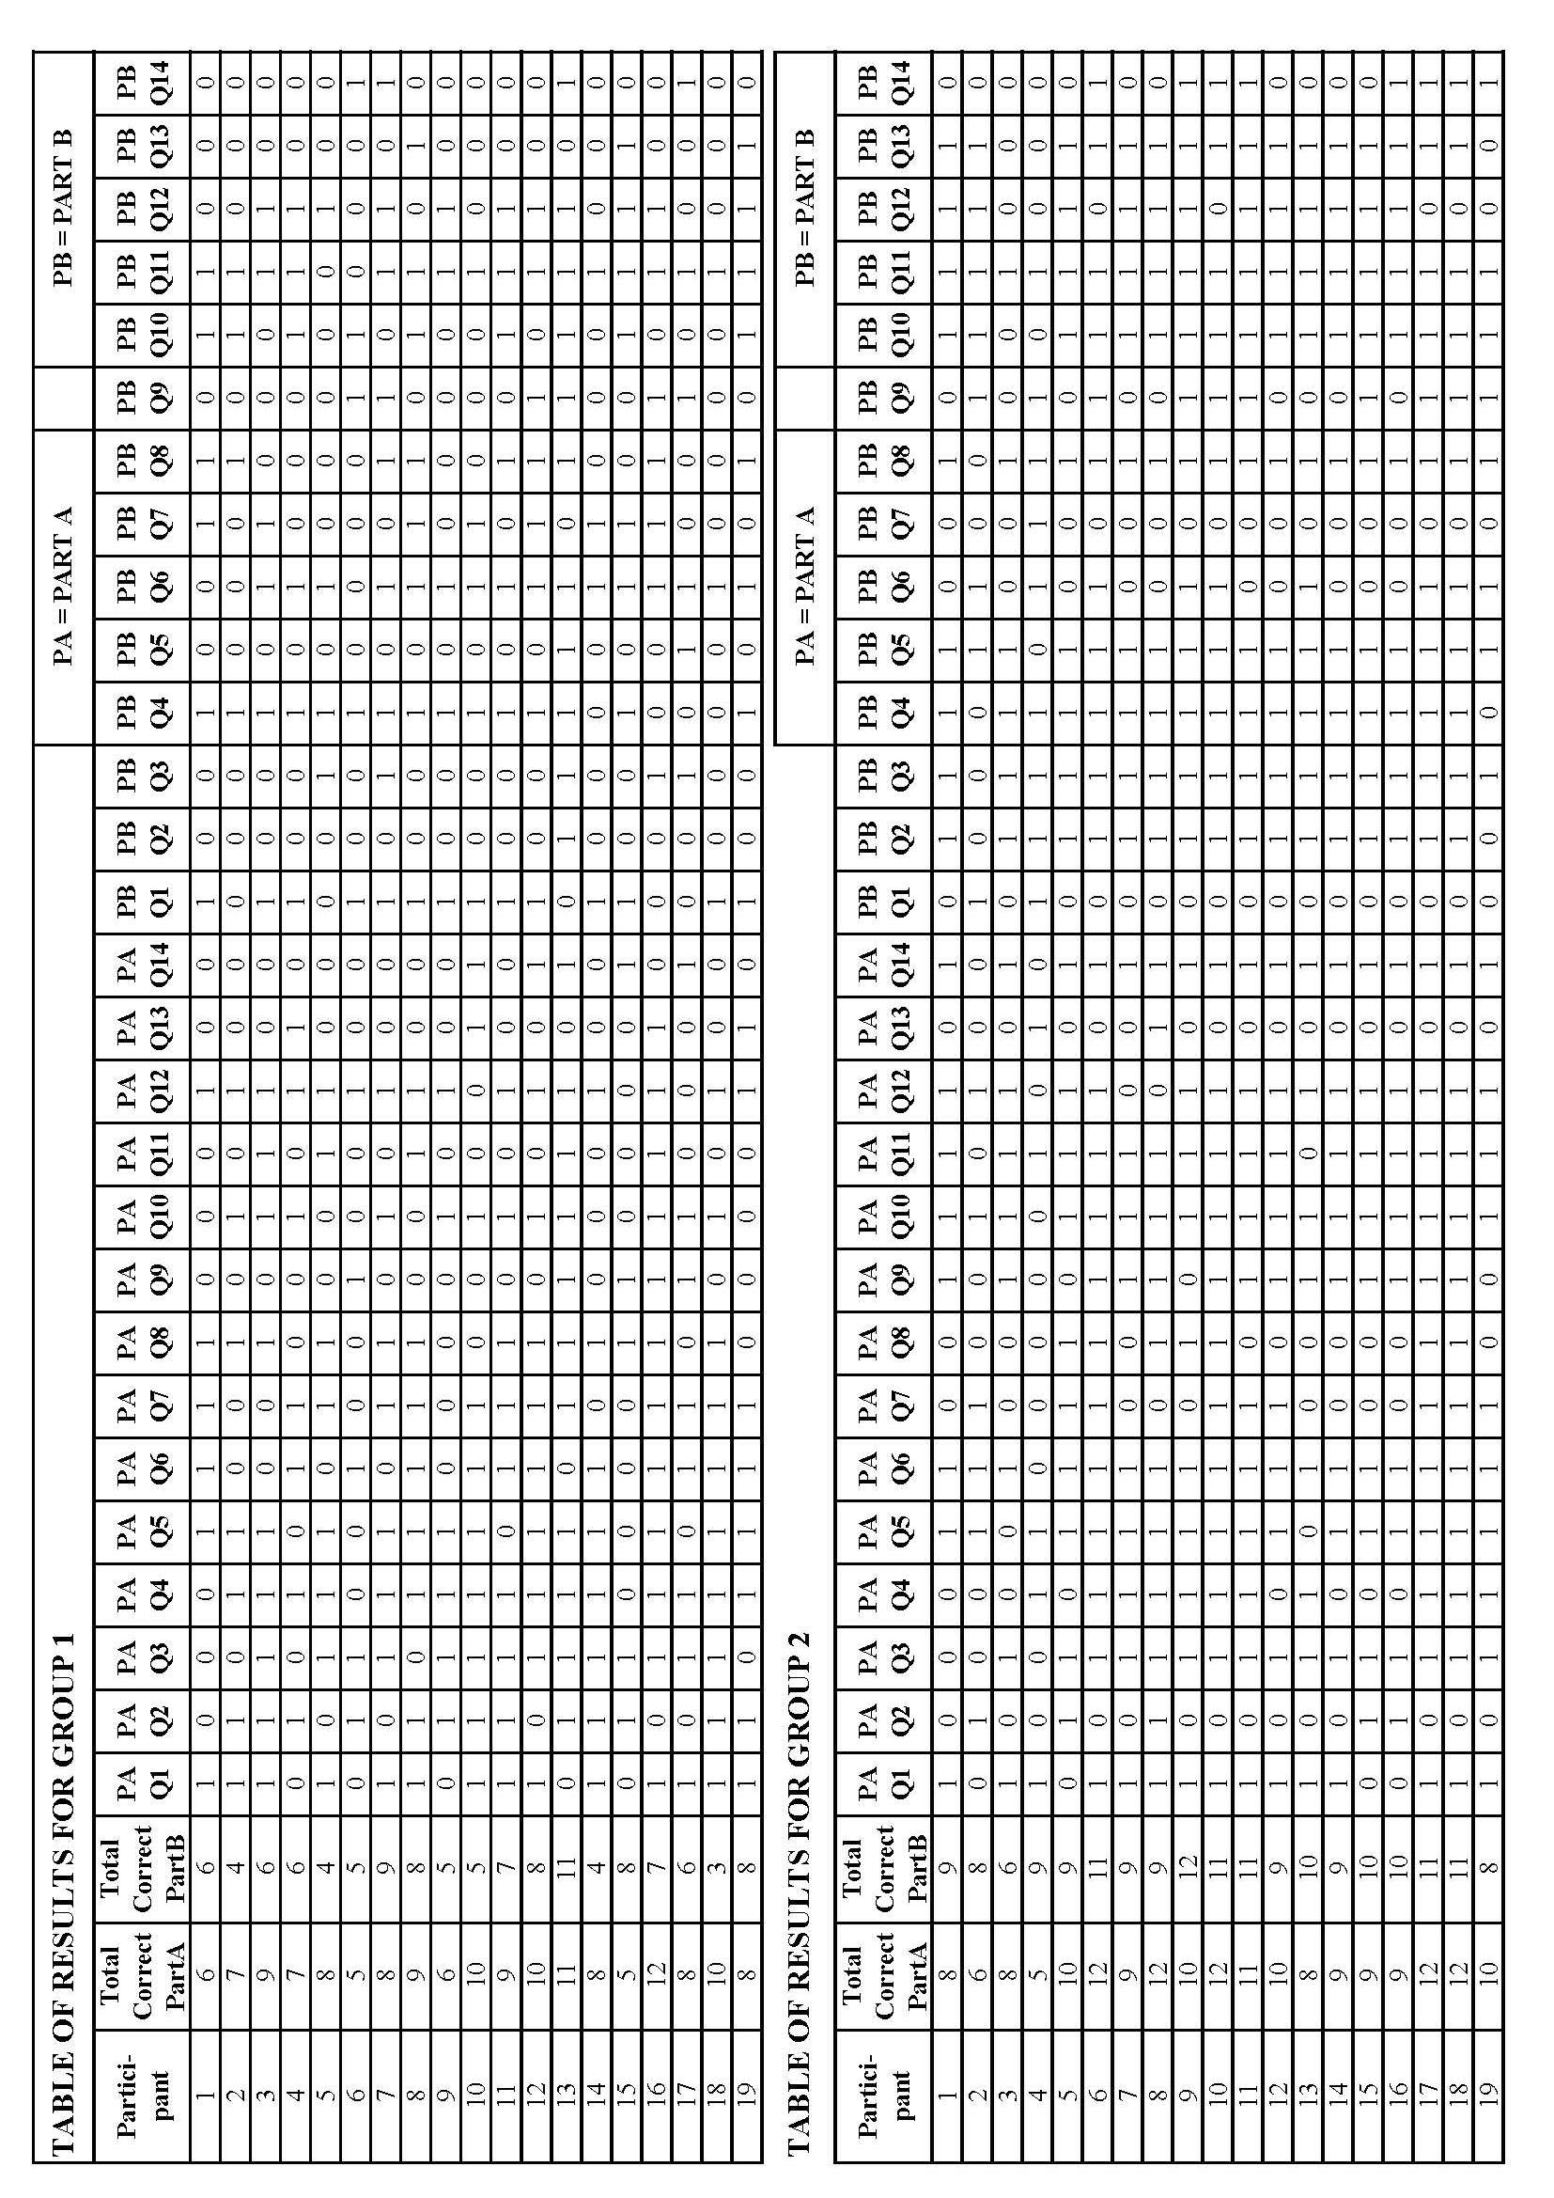
APPENDIX 3: Item Difficulty (p-value) and Discrimination Index
GROUP 1
PART A |  |  | PART B
Question | p-value | Discr. Index | Question | p-value | Discr. Index
1 | 0.73 | 0.33 | 1 | 0.73 | 0.11
2 | 0.68 | -0.11 | 2 | 0.05 | 0.11
3 | 0.73 | 0.33 | 3 | 0.26 | 0.11
4 | 0.84 | 0.33 | 4 | 0.78 | 0.22
5 | 0.73 | 0.33 | 5 | 0.10 | 0.00
6 | 0.63 | 0.00 | 6 | 0.84 | 0.11
7 | 0.68 | 0.44 | 7 | 0.42 | 0.22
8 | 0.68 | 0.44 | 8 | 0.47 | 0.78
9 | 0.26 | -0.11 | 9 | 0.31 | 0.22
10 | 0.63 | 0.33 | 10 | 0.47 | 0.44
11 | 0.26 | 0.56 | 11 | 0.89 | 0.22
12 | 0.84 | 0.11 | 12 | 0.57 | 0.44
13 | 0.21 | 0.00 | 13 | 0.15 | 0.33
14 | 0.26 | 0.11 | 14 | 0.21 | 0.00
Mean | 0.58 | 0.27 | Mean | 0.45 | 0.24
GROUP 2
PART A |  |  | PART B
Question | p-value | Discr. Index | Question | p-value | Discr. Index
1 | 0.78 | 0.22 | 1 | 0.10 | -0.22
2 | 0.26 | -0.11 | 2 | 0.89 | 0.22
3 | 0.84 | 0.33 | 3 | 0.94 | 0.11
4 | 0.57 | 0.44 | 4 | 0.89 | 0.22
5 | 0.89 | 0.22 | 5 | 0.94 | 0.11
6 | 0.94 | 0.11 | 6 | 0.47 | 0.33
7 | 0.47 | 0.67 | 7 | 0.53 | -0.11
8 | 0.36 | 0.78 | 8 | 0.94 | 0.11
9 | 0.73 | 0.00 | 9 | 0.52 | 0.44
10 | 0.94 | 0.11 | 10 | 0.89 | 0.22
11 | 0.89 | 0.22 | 11 | 1.00 | 0.00
12 | 0.84 | 0.11 | 12 | 0.63 | -0.11
13 | 0.10 | 0.00 | 13 | 0.84 | 0.33
14 | 0.89 | 0.22 | 14 | 0.42 | 0.67
Mean | 0.68 | 0.24 | Mean | 0.68 | 0.17

